**Personal Portfolio Template**

(Group number)

(Name – Student ID)

(Github)

**Artefact 1** – (Name of Artefact)

(Screen capture of where it’s used)

…

(Brief description of how it was used/contribution to the project)

…

(Github path for backup and verification purposes only)

...

(Relevant story from sprint - X)

…

**Artefact 2** – Users orm model

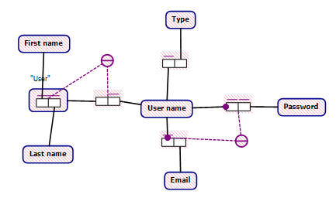

Using an ORM model helps to understand how the data in the users db need’s to be organized. Also this model can help with visualizing data pathways and connections so admin’s can understand the db easier too.p

<https://github.com/MichaelW97/IFB299-top-quality-team-106>

for sprint 1, story 1

**Artefact 3** – Information list page mockup

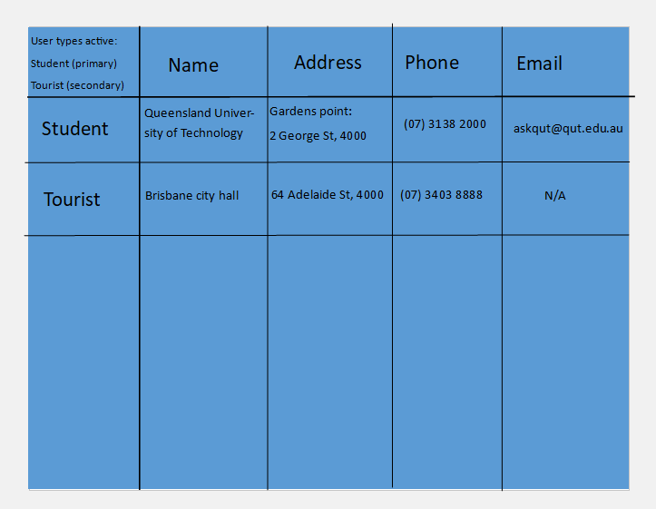

This helps the designers understand roughly how the content of the page will look like when completed.

https://github.com/MichaelW97/IFB299-top-quality-team-106

For sprint 2, story 15

**Artefact 4** – database scripts

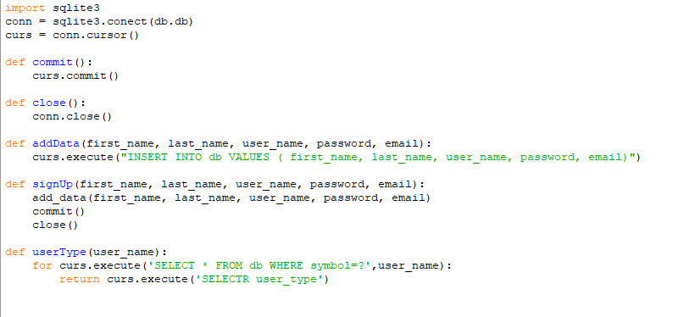

These scripts assist those to work with the database from the html/css layers buy running the functions to add/modify/request data

https://github.com/MichaelW97/IFB299-top-quality-team-106

for sprint 1, story 1

**Artefact 5** – (Name of Artefact)